Yong Zhou #8
Katie and Paul, 09/12 2008

The School

No. 8 middle school is located in the East district of Yong Zhou. It is roughly 1 hours walk to the west side of town, or a short bus ride. There are many small street restaurants just outside the north gate of the school and many more just a short walk away. The are 2 supermarkets close by, one out of the south gate of the school and over the road, and the other is out of the north gate and head towards the river.
The Arts and Office Buildings
from both sides
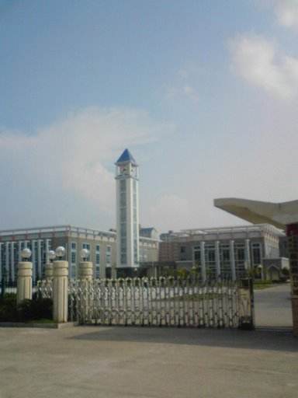
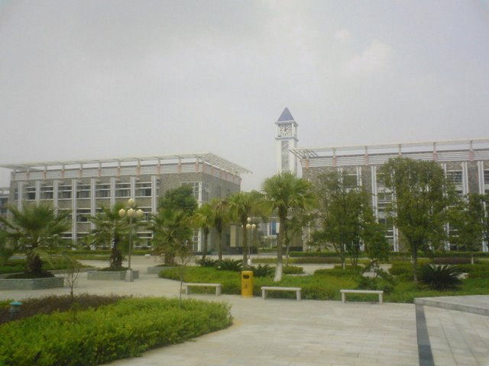

Our Students and Classes

Be warned, the students English level here is beyond low. You have to take things very slowly with them and start at the very basics. There is not a big difference between senior level 1 and senior level 2. We found we could often use the same lesson for each level. Of course you will have those better classes or students that are bright and willing to learn. There are also a lot of students here that aren’t bothered about learning English, as long as they aren’t disturbing the others, leave them be. Class sizes range from about 50 – 60 but most seem to be closer to 50. Their behavior is so so. We found that in the first few weeks they all tried to push their luck but after things had settled own they seemed to come to an understanding with us, if they aren’t interested but are quiet we will leave them alone. Lots of kids using mp3’s and phones but again we made a rule telling them that if they use them in our lessons we will keep them to the end of the day and if it is last period until 5.30pm the next day.
The rooms are very basic. The blackboards are not magnetic (although they are in juniors) so if you want to put any paper on the board you will need tape. They do have projectors and speakers in the classrooms which you can hook up to a laptop or mp3 player. The kids will show you how to use it if you need help but it’s quite straight forward.
We were given the opportunity to teach one day a week at a nearby university. If you are also given this opportunity, take it! We were teaching freshman students and they are so much fun. You can do really fun and interesting lessons with them. Of course there are no behavior problems there and they are all really keen to learn.

The Accommodation

The accommodation is fairly new and modern as it’s only about 3 years old. We haven’t really had any major problems with things breaking and any problems that we have had have been fixed straight away. The apartment has 2 kitchens, two bathrooms, a living room, 2 computer areas and a bedroom. This is because it was designed to be for 2 single people. As it is its very spacious for a couple although I think for 2 single people it would be very small. The kitchen is equipped with a refrigerator, rice cooker, two electric stoves, pots and pans, plates, cups and kitchen utensils.
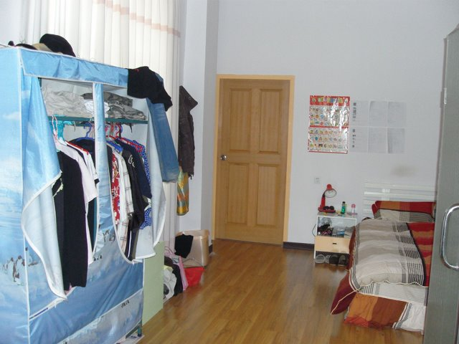
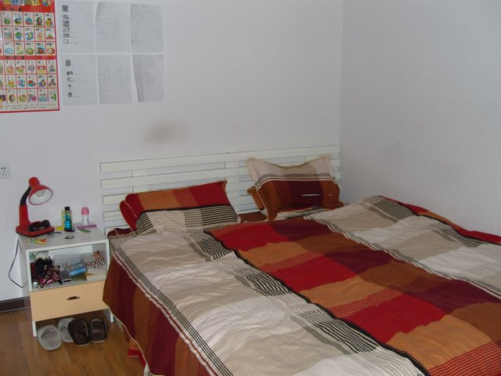

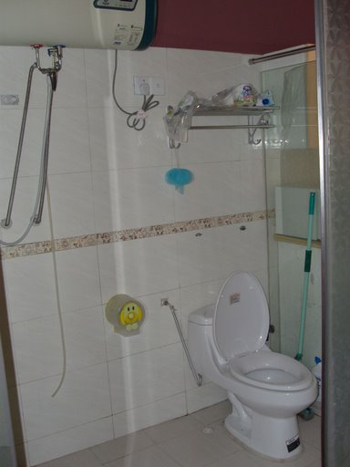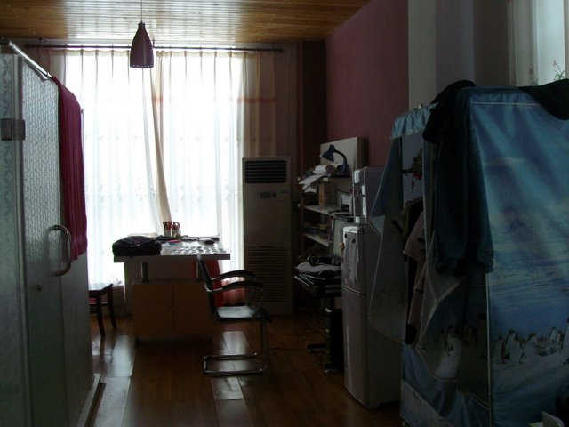
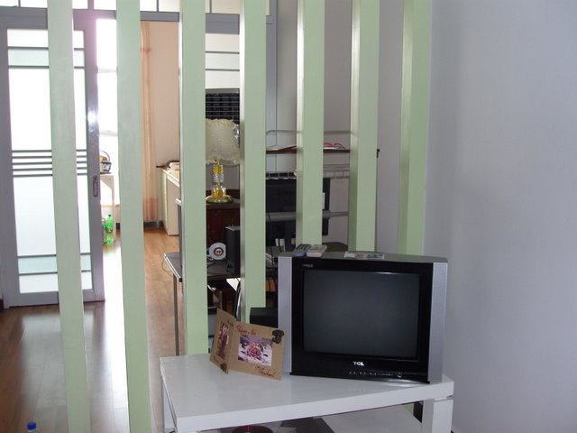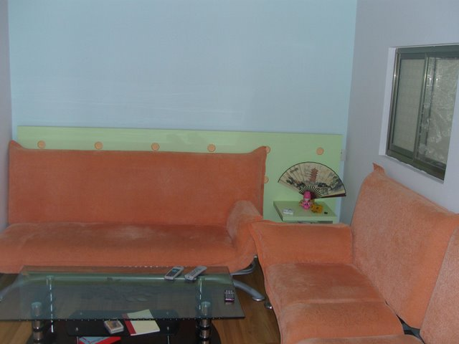

The TV corner and looking through Living room Sofa opposite the TV
the home office and to the kitchen

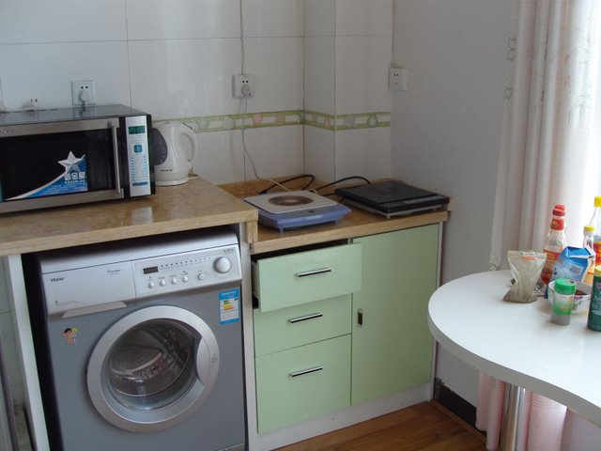

The cooking corner of the kitchen and the washing machine

The only bad thing about the apartment is that it can be quite noisy. It is right next to the square where they do their morning exercises and also opposite the music rooms, which can be quite noisy, sometimes very early in the morning. Earplugs might be a good investment!!
But of course on the plus side you are only a short walk away from you classes (about 5 mins)

The City
Yong Zhou is mainly split into 2 districts, the east and the west. There is also another district of the city called Ling Ling but that is 40 minutes away on the bus. School no. 8 is located in the east district. The east district is much cleaner but also considered to be more expensive, as there are a lot of government workers that live in the east. The west side is just over the river. It is much dirtier but also the shops are cheaper. There are a lot more shops and restaurants on the west side, including a KFC!
The people are all very friendly and helpful even if they can’t speak English. Of course there will be the inevitable stares but only because they are curious, and you soon get used to that.

Transportation

Getting around the city is very easy. There are many buses which all cost 1 yuan. If you catch a number 8, 10, 20 or 28 they will all take you over the river to the west part of town. I think the number 20 and 28 also can take you to the train station. Taxis are pretty cheap to (we tend to catch them if we are out late at night) There is an automatic charge of around 4 yuan. To get from the west to the school costs about 10 – 12 yuan.
Yong Zhou also has 2 bus stations and a train station so it is well connected to get around. You can get regular buses to Guilin and Changsha both about 3 – 4 hours away. Also if you want to visit a couple of smaller towns, Dao Xian and Xin Tian are only a couple of hours away. Trains can take you to most places you want to go and Lily (your FAO) will be more than happy to help you with that.

Food and shopping

The food in Hunan is well known for being spicy. There are many restaurants and street markets where you can get all kinds of delicious food, ranging from the exotic, like snake and dog, to the normal, like cabbage, beef and pork. I would highly recommend trying anything if you are the adventurous type as we have found everything to be good. There is a night market on the west side of town by the river which does excellent BBQ. For those of you craving western food you do have a couple of options, KFC (2 on the west district) and Milo coffee and Golden coffee, in the east district, near to No. 4 school. There are also various bakeries scattered all over town where you can get some bread and pastries and such although it’s all quite sweet.
The food markets are great for shopping and everything is much cheaper and fresher than in the super markets. If you are going to buy meat from the markets I would recommend getting up early so that it hasn’t been sat out all day.

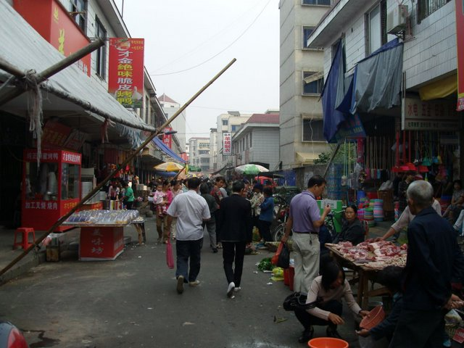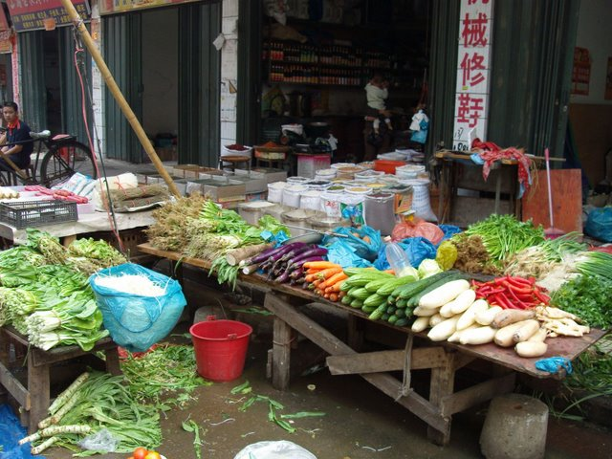

The best supermarket is in the west district near to KFC. You will be able to find, peanut butter, jam, ketchup and a kind of mayonnaise (not quite the real thing) there.
Shopping in Yong Zhou is good as there seems to be an endless amount of shops but be warned if you are bigger than the average Chinese person it could be difficult to find things big enough. Especially shoes! But if you are willing to look you can find some stuff to fit. If not wait until your holidays and travel to a big city so that there will be more variety in sizes. But you will be able to find almost anything else you need as there are shops selling everything.

Entertainment

There is plenty to see and do around Yong Zhou. Of course there are numerous KTV’s which are always good fun with a crowd of you. If you head down to the west district in the evening you will see people doing karaoke on the streets, and its always good fun at the night market.
At the park by the river (near to No. 8 School) there is dancing every night from 7pm – 9pm. There are a few different kinds of dancing there and Lily goes down most evening so she will be happy to take you and show you how it’s done. Also next to where they do the dancing are little amusement attractions and roller skating! Further down the river there is Tai chi in the evenings from 7 – 9pm. If you are a newbie like me it will be hard but if you persevere you will get it in the end.

Attractions

There aren’t huge amounts of attraction in Yong Zhou but over in the other district, Ling Ling, there is a museum and an old temple. Also surrounding Yong Zhou are many mountains great for hiking when the weather is nice.

Other info

Lily will be providing you with 2 Chinese lessons a week, which are very helpful but you will need to practice yourselves when you are out and about.
Both of your FAO’s (Lily and Smile) are excellent and very helpful.
The school is very into its government regulations and rules as well as the safety of foreign teachers so you are always taken care of and well protected.
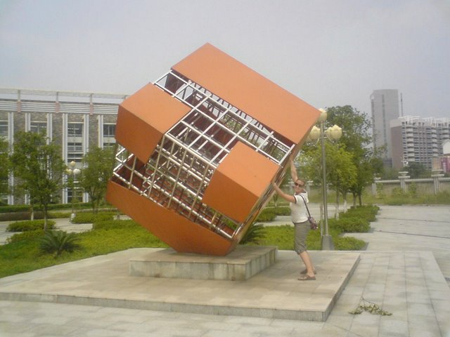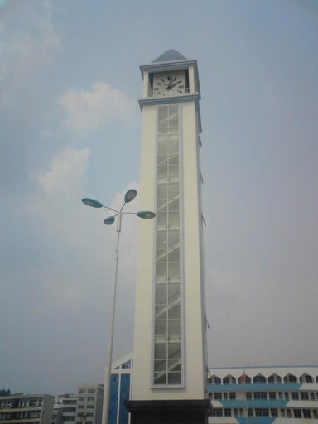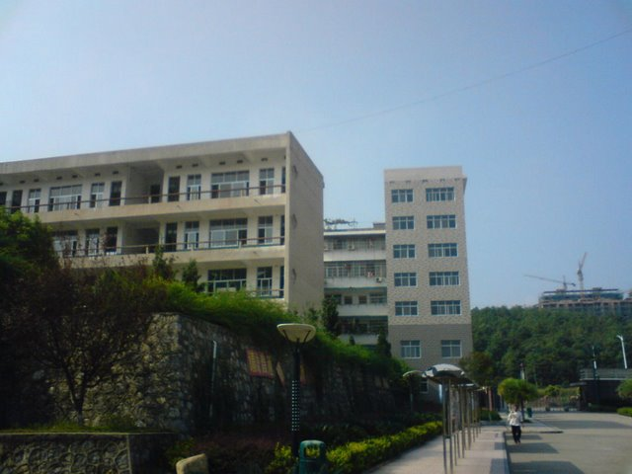

Katie holding up an interesting The Clock Tower The teaching buildings where all classes sculpture that’s on campus. are held.
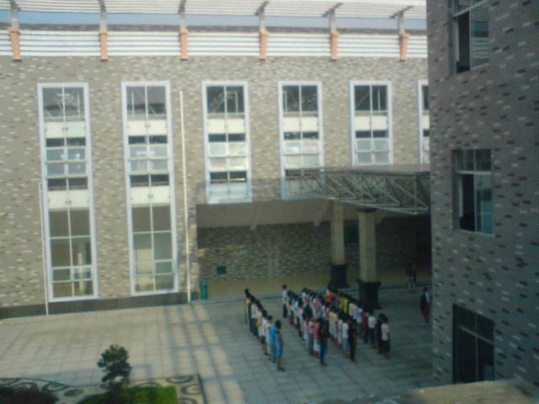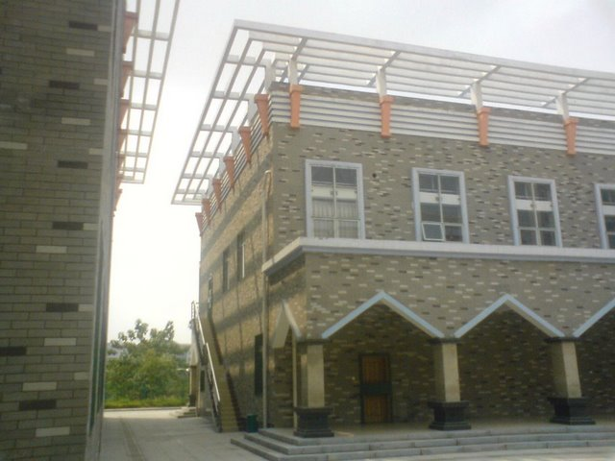

Students between the administration and arts The stairs up to the foreign teacher’s apartment.
Buildings; they are probably doing Phys Ed

