Life in Ankang City and Teaching at Peixin Primary School
Roslyn Hamilton – February – July 2009
Life in Ankang City
Ankang is in the south of Shaanxi Province. The capital city of Shaanxi is Xi’an – home of the terracotta warriors.
Ankang is a small Chinese city of approximately 230,000 people and is a very pleasant and friendly place to live. It has a beautiful river running though the middle of it with a walking promenade. It is surrounded by countryside which you can easily access by foot, bike or bus. The local farms grow vegetables, rapeseed for oil, and fruit. In fall the fields were yellow with flowering rapeseed, and the beautiful pinks and white of fruit blossom. The local farmers are very friendly and hospitable as you walk the country tracks and love to offer you a seat to rest and a glass of green tea.
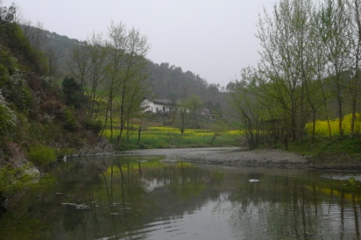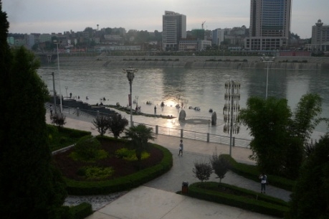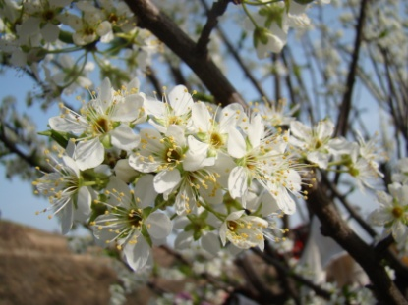
There are also other places to visit in the nearby area – villages, mountains and lakes. Or you can go by train or bus to visit other cities. A huge plus is that the air is relatively fresh. Some days may be hazy in the distance but there is no heavy pollution.
Within the city there are markets, shops, supermarkets and bars – but it is not a Western city. During my stay there were 8 foreigners – all teachers - and we were a novelty. The local people are amazed to see a foreigner walking around in their streets, and love to practise their few words of English with you – so you are always greeted with a chorus of ‘hellos’. Their faces break into smiles when you greet them with some Chinese words.
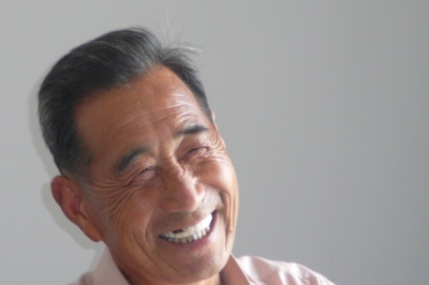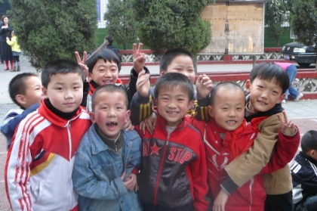
The people are very friendly, kind and helpful. Foreigners here usually make good Chinese friends who love to help out when you need a translator, show you where to go for everyday necessities, and enjoy showing you around their city. One couple in particular like to adopt foreigners in the city, and become good friends and are invaluable in their kind assistance and friendship.
Over the years foreign teachers of all ages have come and gone – from university graduates to retired people. Some have had commitments in their home country and only stayed one term, whilst others have stayed for several years. It is a good place to call home. During my time here, we got together officially one night a week for dinner, and more frequently on a ‘as it happens’ basis. It is good to have other ‘colleagues’ to share experiences with. There are two foreign teachers at Peixin Primary School and it is great to have each other’s support.
A weekend to Xi’an is easily managed taking 4 hours by train or 2 hours by bus on the newly opened highway. Everyone enjoys the chance of being in a bigger city with lots of Western touches and it is a very beautiful and historical city to explore, shop in, and have ‘a fix’ of Western food. There are also big supermarkets where you can stock up on some supplies. It is nice to ‘spread the word’ and meet up with other people from Buckland’s who are also in Shaanxi province. However Xi’an tends to be polluted and it is nice to return to Ankang.
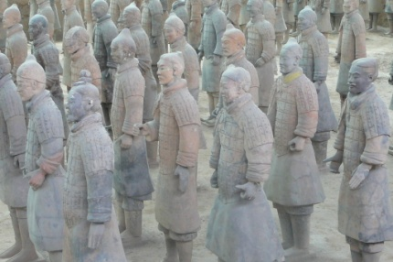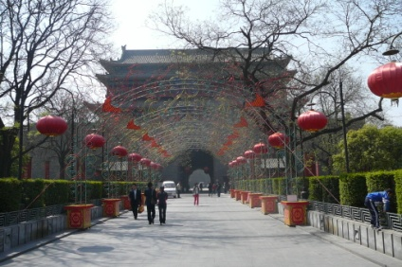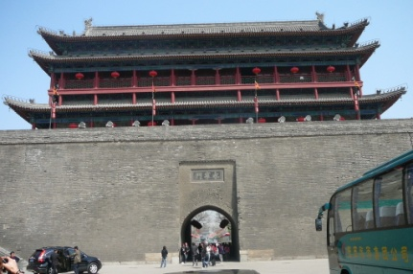
KFC has found its way to Ankang and there are a couple of other places that sell Western food – but it is more expensive than the local fare. Many restaurants and street stalls keep you well provided with eating options. The local specialty is Ankang noodles. The food can be spicy – but you can always ask for it to be not spicy. Peixin street is full of fresh fruit and vegetables, street food stalls, and little restaurants.
Teaching at Peixin Primary School
The leadership team and the Foreign Affairs Officer have looked after me very well. They gave me a warm welcome, took me out for dinners and on excursions into the countryside. The FAO has always been very helpful and attended to any requests I have had and answered my queries.
It is a bonus to have two foreign teachers at the one school as you can share teaching ideas and experiences with each other and be of support to each other as you experience the highs and lows of living in a foreign country.
There are three Chinese English teachers who work with you and share the English Office. They are friendly and helpful. You also have a teaching assistance who attends classes with you. Their job is to ensure the students listen to you, and translate for you when necessary. They also look after your welfare and are of assistance with all the little and big things that you need to know about life in Ankang.
The apartments are on the boundary of the school and it takes 30 seconds to get to the English office and classrooms. This is handy, but it also means you hear the children in the playground and the bells going from 7am. The apartments are old and not luxurious, but okay – and you soon make them your own with your personal touches! They are cold in winter with little heating. But an extra heater would make a difference.
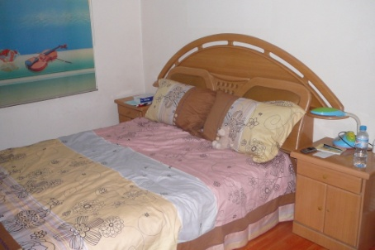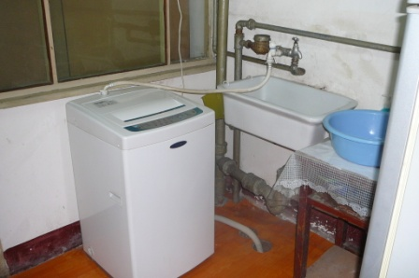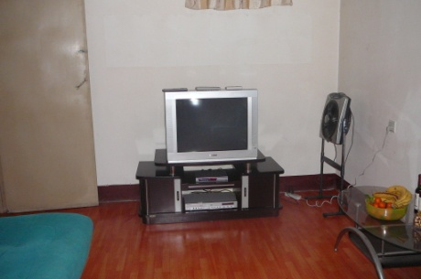
The teaching is demanding but it starts to fall into place once you set up your own routines, structures and expectations of the students. Most of the classes and students are good, but some are a little more challenging than others! Class sizes vary from 50’s – 70’s.
In this school you are the main English teacher for the classes you teach. You take each class for 3 lessons a week and the Chinese English Teacher takes them for one. This means that you prepare about 10 different lessons a week. There is a class textbook which you follow, but to which you can add in your own personal style and touch.
Living and working in a foreign country and culture comes with frustrations, communication difficulties and maybe some misunderstandings. This is to be expected. I think it is important to ‘go with the flow’ and not get upset about things that you may not always be the way you think they should be. If difficulties do occur, a gentle approach to your FAO rather than an aggressive one, will achieve far better results!!
Good luck with your teaching and stay in China – whether it be in beautiful Ankang, or some other China destination.
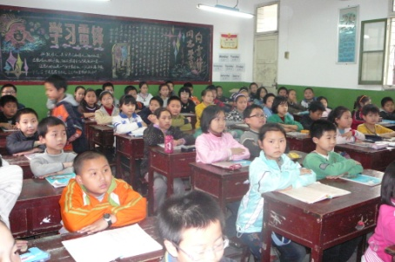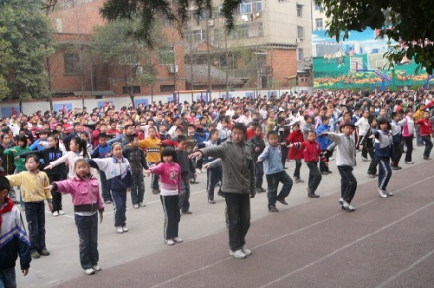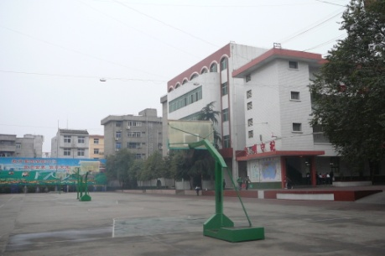

Life

