Teacher feedback for Qiyang #1 Middle School, Hunan Province
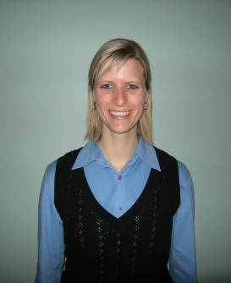
By Melanie Rankin, Australia (2009 foreign teacher)

The school
The school is called Qiyang, #1 Middle School and it is located about 45 minutes (bus ride) from Yongzhou City. Qiyang #1 Middle school is the best school in this county. Senior 1, 2 and 3 attend this school. The school itself is 97 years old. It is like a big park as it has many tall trees and it is just a lovely environment to work in and it is very well maintained in terms of landscaping and cleanliness. There are approximately 3,000 thousand students at the school and most of them live on campus.
For me, living on campus is very convenient and it is only a short walk to each class. It does have some downfalls though i.e. it can be very noisy and disruptive to your private life. For example, the first school alarm rings at 6:00 am and the “wake up tune” goes for 15 minutes. The last school bell rings at 10:20 pm. The school bell is very loud and runs for about 10 seconds each time. My apartment is near the basketball court and the ping pong tables, so it gets quite noisy when the students are playing and shouting as they get very enthusiastic about their sport! You can either join them, get used to it over time or zone out from the noise!
Each classroom has a data projector screen and speakers so it is an excellent teaching tool. I create all of my lessons into Power Point slide shows and I use a lot of images and sometimes I use sound. 99% of the time the data projector works, however sometimes it can switch itself off due to the heat or sometimes I would turn up to a class only to find that the data projector had been taken away for repair…so you must have back up or know how to improvise on the spot!
Regarding my teaching schedule, I teach 18 classes a week and each lesson is 45 minutes. My earliest start is 8:05 am and my latest finish is 5:00 pm. Sometimes I have 10 minutes in between classes, other times I have a 4 hr & 25 minute break in between classes, [which includes lunch], or a 55 minute break in between classes – there is lots of flexibility. I also get a lot of extra days off because the students have exams quite frequently and there are many public holidays too. Expect to have sudden timetable changes too!
The school is very secure. There are big electric gates at the entrance of the school. A gatekeeper is in charge of who goes in and who goes out of the school. Each night, the gates are locked at 10 pm. If you come back to the school any later, you will need to make quite a commotion to “wake up” the gatekeeper. I avoid this situation, but there have been a couple of instances where I have returned back to the school after 10 pm. The school has never stipulated a “curfew” to me, but it isn’t pleasant waking someone up so I try to avoid the situation!
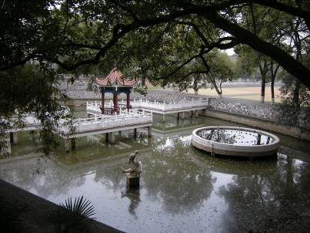
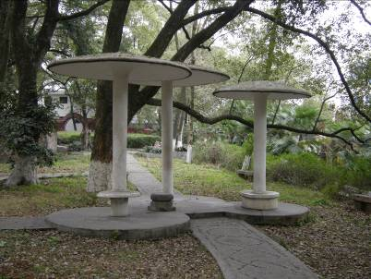
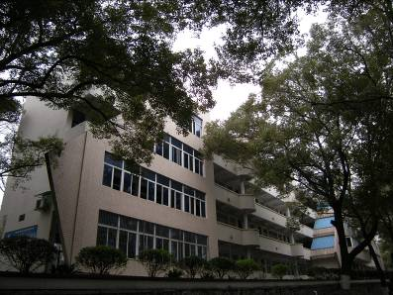
Senior 2 building Pond with oval in the background School garden
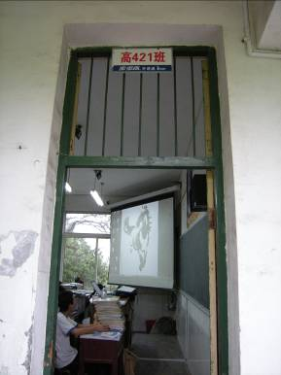
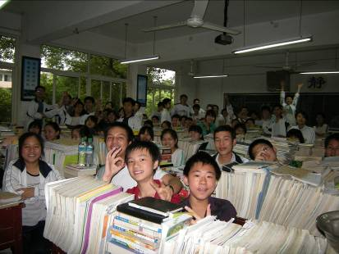
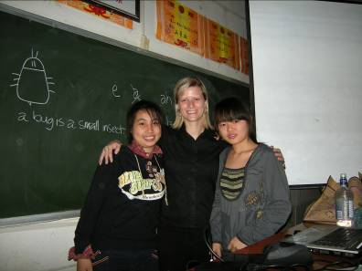

Entrance of classroom Inside the classroom Front of the classroom
The students
I teach Senior 2 level [senior 3 do not have oral English classes]. My smallest class size is 51 students and my largest class size is 69 students. In total, I have 1,118 students during the week. I have 18 classes from Monday to Friday and each class is 45 minutes duration. Not all students have an English name. Some have asked me to give them an English name which is a true honour! I looked up several name choices for them on the internet and gave them the meaning and let the student choose their name from the selection I gave them. I also offered to give a couple of students an English name as they were such nice students, but I just couldn’t remember their Chinese name...let alone pronounce them! They were very excited that I offered to give them an English name.
When I first started teaching here, I had to be very conscious of speaking very slowly and loudly, both of which are unnatural for me to do. I asked each class, “Can you please do me a favour? If I am speaking too quickly, tell me and/or if I am speaking too softly, please tell me!” I would use my arms to motion a gesture for speak up and slow down. They understood that and they feel special if they think they are helping you.
Overall, the students are really motivated and enthusiastic about study in general as the college entrance exam means everything to them. Some students are more enthusiastic about English than others. There are 4 top classes in Senior 2 and the classes are determined by their exam grades. I rarely had any discipline problems and nothing I couldn’t handle myself. I did a “rules” lesson in my 2nd week of teaching to set some boundaries for the students. Throughout the weeks, if I ever had a disruptive student, I would stop speaking and focus my eyes on the disruptive student and the other students did the same until the disruptive student realised everyone was staring at him/her. Sometimes actions speak louder than words. Or I would merely remind them that if they are not interested in English, then that is fine by me, but respectfully asked them not to spoil the lesson for their classmates. Or, I would say to the disruptive student, if you are not interested in paying attention, you can stand outside of the classroom and explain to your head teacher why you are outside of the class room. Usually my demeanour is very friendly and outgoing in class, so when I show them a serious tone, the students get the message pretty quickly.
Although many of the students are very outgoing, there are also many students that are very shy, meaning, they are too shy to speak in class, but they do listen attentively. Over time, I built the trust of many students and their confidence which was a very rewarding feeling, but it required a lot of patience on my behalf. The students pick up on your qualities very quickly, so just give them time.
On the contrary, when I first started, I had a few students trying to tell me what topics to teach and how I should teach the topic and what I should wear i.e. don’t wear black clothes! I found this type of student attitude very confronting, but I politely told them that what I wear is my personal business and thanked them for their feedback regarding my teaching and listened attentively. I also politely reminded them that I was the teacher, that it is impossible to please 1,118 students with every single lesson that I do and that I also had to work within the expectations of the school leaders, eventually they relented on these topics.
The students are really interested in Western countries, culture and customs and western currency and of course they are very interested in you and your hobbies. The students love to sing and always ask me to sing and dance. I can’t dance, but I give the singing “a go”, even though I can’t sing, the students still appreciate that I tried!
When I first started teaching, the students were keen to take my photo, ask for my email and mobile phone number. I agreed to all three, but I made a rule with the mobile phone, they must not ring before 8 am or after 8 pm. I had to set some rules because I was getting calls/messages at inappropriate times! Also when I first started teaching here, a few students had a habit of comparing me to their former foreign teacher. It just takes them some time to adjust to you, get to know you, your teaching style and your accent!
The students go to school 7 days a week here, but all students get 2 hours free on Sunday afternoons. Quite often, my students will invite me out to have noodles or dumplings with them, help me with my grocery shopping or I play ping pong with them. It is a good way to get to know your students and gives them a chance to practice their oral English. They look at you not only as their oral English teacher, but also as a friend. They are also more motivated in class to participate when they feel they have a one on one bond with you.
Along with the other foreign teacher here, I also assisted the students with their ‘student radio club’. Student radio club is held on Mondays from approximately 6:00-7:00pm. Sometimes we would just read an English article over the P.A and other times the students asked us to prepare something about a particular topic related to our home country.
I also used to co-run ‘Movie club’ once a week in the multi-media room. This took approximately 1 hour of our time. There was a big downfall to this though. The data projector and/or sound rarely worked in the multi-media room and after numerous attempts to get it all working, it just never happened so after about 10 weeks we eventually gave up on running movie club.
English corner is another popular activity for the students. Again, the other foreign teacher and I worked together to run English Corner. We ran it once a week and it usually goes for 45 minutes - 1hour. It is an optional activity that the students can come to where they can practice their speaking and listening in a less formal environment. This activity attracted mostly senior 1 students as the senior 2 students have a much busier study schedule than senior 1.
My apartment
My apartment is private [as they all are] & is pretty well decked out in terms of Western style living standards. When I arrived at the school, the apartment was very clean. The school also purchased me a brand new set of bed linen, two pillows, [the mattress was also new I think! - Although very firm, it is a decent large size]. I had to ask the school for a ‘spare’ set of bed linen as it is extremely hard to dry washing here when the weather is cold. I also had to purchase my own set of towels.
It was very cold here at the end of February, although it was still spring, there was a cold snap, so I had to buy an extra blanket & I bought a small electric hand warmer. The school did buy me a small portable heater which helped. There is an A/C unit in the bedroom which acts as both heating and cooling, but it never seemed to get very warm and it is only a small unit, so it is only capable of heating up/cooling the bedroom, not the rest of the apartment. The bedroom is a decent size & has excellent wardrobe space & two bedside tables with three drawers in each and a coat stand. Although there are flyscreens on most windows, the creepy crawly bugs and beetles still manage to find their way in! But I invested in a big can of insect spray & this works most of the time...for the bigger ones; I call on the other foreign teacher who lives opposite me!
In the kitchen, I also had a new wok, rice cooker, crockery set, chopsticks & holder, mop & buckets & bins. The apartment already had a knife block set, small fridge & microwave, both clean & ready to use and a plastic stand with four shelves to store my food on (there are no cupboards or shelves for food storage). I bought my own drinking glasses & hot drink cups, although there were disposable plastic cups in a packet when I arrived supplied by the school. I bought my own saucepan with lid which can be more convenient than using the wok sometimes. Although the school provided me with “some” cooking utensils, I also bought my own cooking utensils such as a grater, colander, teaspoon, dish rack to drain my dishes and some other bits and pieces…I even found a butter knife & fork here so I bought one of each just for a change from the chopsticks from time to time! In the kitchen, there is no hot water tap for the sink. I have a large gas bottle that services a bench top stove with two burners, although I can only ever seem to get one burner working, but it’s not a big deal. I boil water in the wok and use that water to wash my dishes in a large plastic bowl.
The washing machine is also fairly modern & easy to use. Of course the electrical goods are all written in Chinese, so you will need to ask your FAO for instructions on how to use them. I live on the 4th floor & each apartment has its own balcony. There is a line affixed on the balcony for drying your clothes. I bought my own ‘circle peg clothes hangers’ for my “smalls”. I purchased my own iron and ironing board. I also bought some small carpet mats as the floors are very cold to stand on in the cold weather.
The study/computer room is very spacious which looks out across my balcony where I have a nice view of the river and I feel like I’m amongst the tree tops! There is also a wall unit in the study, so that is very handy for storing crockery etc. The school did supply me with a laptop, but some of the keys were missing and they couldn’t find the power cable for it, lucky for me I brought my own laptop. The internet is provided free of charge, but it doesn’t always work 100% of the time and sometimes I have trouble accessing sites, even Facebook. I have heard many foreign teachers have this problem in their school, so it’s probably just one of those things you can’t do much about.
The school also provided me with a mobile [cell] phone, but most of the writing on the key pad had worn away and again, I preferred to use my own mobile phone that I brought with me. All I had to do was get the FAO to assist me with setting up a China mobile sim card.
The bathroom is more like a small en suite. It has a Western toilet (of course) and an electric hot water service tank which is suspended above the shower head. Although I am really satisfied and comfortable in my apartment, I will admit that the water supply has been sub-standard. The sort of problems that I have encountered include; the running water cutting out completely at random times, very low water pressure or no hot water at all. This is not the case everyday for each problem, but one of these problems does occur at least every time I use the shower. I have repeatedly reported this issue to my FAO and he suggested that the school is an old building, so perhaps the plumbing isn’t always running efficiently. Eventually, I had one too many cold showers and I reported the problem again and the FAO organised to have the shower hose replaced. So far, the hot water hasn’t cut out since the hose was changed, but the water pressure can still be very limited and maybe once or twice a week the temperature and water pressure is fantastic! I think it is just one of those things that can’t quite be fully fixed, so I have learned to adapt to it.
The living room has a large colour TV, but no TV channels. It is only useful for watching DVD’s. I have two hard timber arm chairs in my apartment which I find to be very uncomfortable, so it’s not very relaxing to watch DVD’s; no matter how many cushions I use to make the chairs more comfortable! But it’s not really an issue; I do not miss TV that much & rarely have time to watch a DVD. The living room also has an excellent water dispenser that has constant boiled water or just cold drinking water. The water re-fill bottles are available from the janitor’s room and I have never been charged for the drinking water.
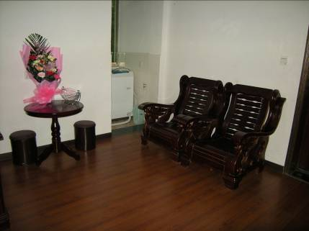
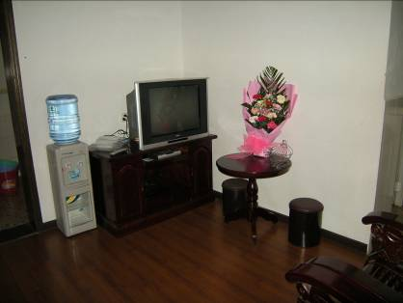
I live on the fourth floor [it’s like a block of flats], so you can hear other teachers coming and going and I can even hear them chopping up food!

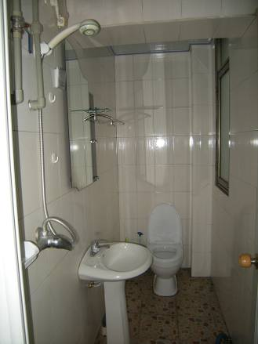
Living area Living area
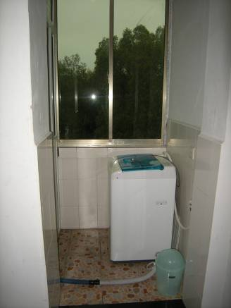

Washing machine Bathroom
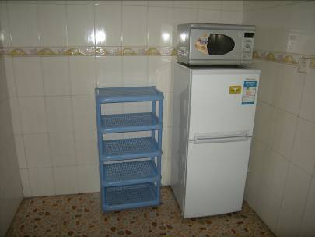
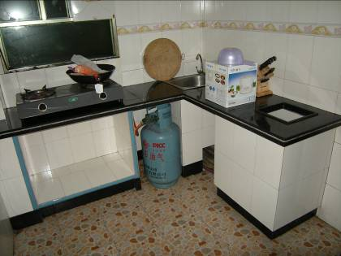

Kitchen Kitchen
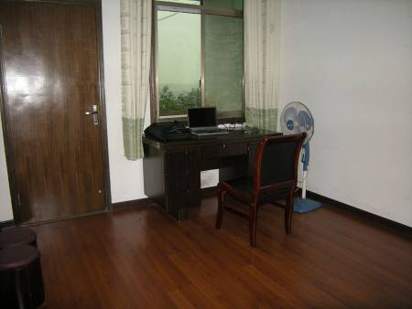
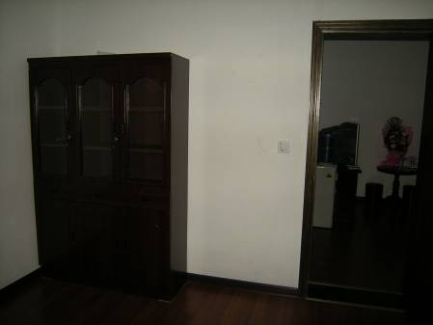

Computer room with a view! Wall unit in computer room
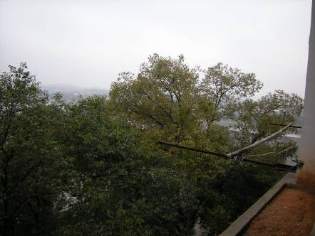
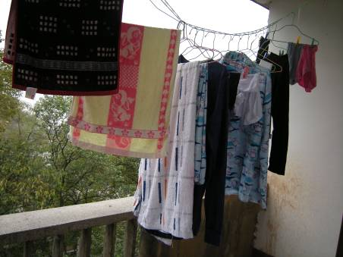

My balcony washing line Partial view from balcony – up in the tree tops!
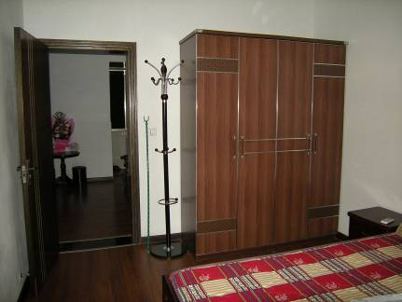
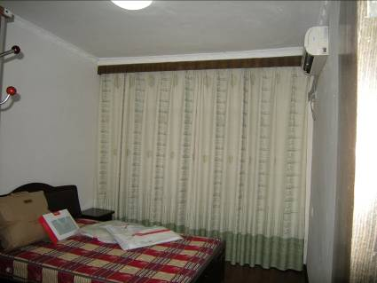

Wardrobe & coat stand in bedroom A/C & heating unit in bedroom

School staff
When I arrived at the school, I was greeted by about a dozen school staff members including Chinese English Teachers (there are approximately 31 C.E.T’s), senior teachers and school leaders. At the time of my arrival, the school Principal was busy with a prior engagement. They were all very friendly to me and made me feel very welcome. I was also presented with a gorgeous bouquet of fresh flowers (see my living room picture above). Then about half of them all escorted me to my apartment and helped me carry my bags. They showed me around the apartment and made sure I was happy with everything. Then they gave me a short amount of time to get ready as they wanted to take me out to my ‘welcome dinner’. About 10 people attended the dinner and I have to say, the Chinese hospitality is ‘second to none’ and they made me feel like a celebrity!
The FAO (Foreign Affairs Officer) has fairly good English and he always tries his best to fix any problems that may arise with the apartment or answer any questions I may have about the school etc. He also teaches Geography 7 days a week, so he is extremely busy, but tries his best under the circumstances. Sometimes you can find out information from the students before the FAO has a chance to inform you. I have also made friends with some of the other C.E.T’s here and they are happy to help with any questions you may have. But because they work 7 days a week, it is sometimes difficult to contact them, but between the FAO, C.E.T’s and the students, you are bound to get an answer one way or another!..Worst case scenario, you can always rely on Buckland’s to help you.
On several occasions, without any warning, some C.E.T’s will appear just before I’m about to start class and ask my permission to “observe” my class. I always say yes and they are just happy to sit up the back of the class and watch what you do and how you do it, you don’t even realise they’re there!
I have been taken out to two welcome dinners. The first one was the evening that I arrived; the second one was so the school Principal could attend. The Senior 1 department has also included me in two “thank you” dinners and my senior 2 department has taken both me and the other foreign teacher out to one dinner. All dinners are fully paid for, including the transport of getting there and back. The dinners are fantastic and they take us to the best Chinese restaurant in Qiyang every time!
Environment
The weather here is VERY changeable!! As long as you dress sensibly and can accept that there is nothing you can do about the weather, then you’ll cope with it! When it rains, which is very often, even in summer, the roads and footpaths are very slippery and uneven in parts, so it is a good idea to have sensible walking shoes with a decent sole, even waterproof shoes are a good idea. The roads/streets also get very dirty, so it’s a good idea not to wear white or light coloured shoes here. Having said that, you can get them cleaned by a street vendor for 1 Yuan – very cheap! I will provide a link to the Qiyang weather forecast: http://weather.msn.com/local.aspx?&wealocations=wc%3a27044&q=Qiyang%2c+CHN&setunit=C
I also find the air to be fairly clean. The only time it really smells is when the locals or the school are burning off their rubbish. My other weather observation is that when it is hot, it is very humid. It feels like my whole body swells up and I can feel the sweat dripping all over me. It’s rather uncomfortable, but that's humidity for you! There are ceiling fans in all classrooms, an A/C unit in the apartment bedroom and a pedestal fan in the study, so you can find some comfort and relief from the humidity!
I have also noticed that when it is hot, the sky can be very clouded over, so you can’t actually see any blue sky or the sun itself. It is more likely to be clouded over than to see a sunny blue sky, but rest assured, you will see it from time to time.
I am told that the winter is meant to be very cold in Qiyang. It is well worth bringing some thermal underwear like long sleeve thermal singlets & long johns. I am a size 10-12 [average size in Australia], but I have had trouble finding clothes to fit me. So, keep that in mind when you are packing! People will tell you can “buy anything” in China – that may be true, but not necessarily in a small town!

The city/things to do
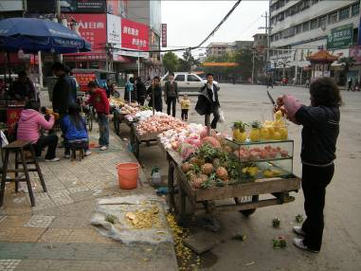
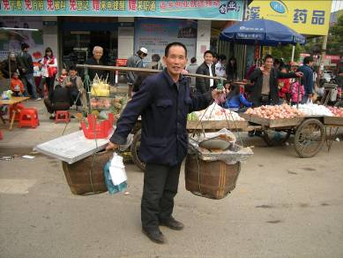
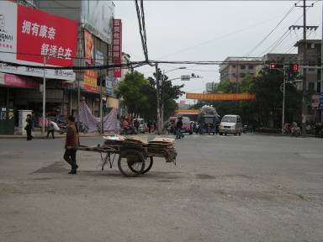
Qiyang is an easy town to adapt to. It has a population of about 1 million people and it is close by to peasant farms and the countryside – good area for bike riding. It has many retail shops, street vendors that sell all kinds of things from fresh produce to pig’s penis on a skewer which can be barbequed for you while you wait! Qiyang also has three supermarkets where you can buy most groceries from, but very limited Western items/brands.

Typical street vendor Friendly local! Main cross road in town
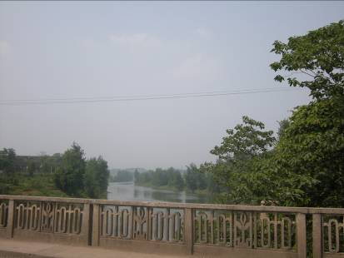
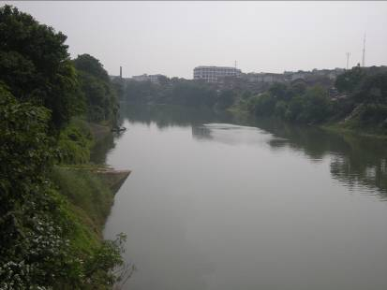
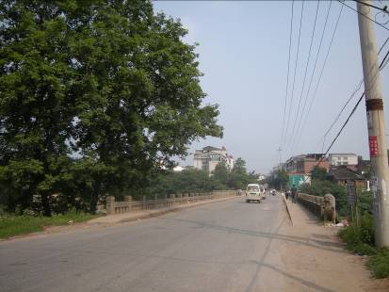
The Xiangjiang River runs by the school. On a clear day, it is quite a nice view from the apartment balcony with the mountains in the background.

Looking to right (city bound) Looking to the left (city bound) Heading back to the school



The Wenchang tower was built in Ming Dynasty and destroyed later. Then it was rebuilt in Qing Dynasty. It has seven floors with eight doors on each floor. There is a shrine for idols or gods on each level.

Wenchang tower (walking distance from the school)
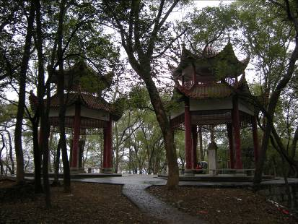
The two Pavilions represent the sacrifice of the revolutionists during the time that China became the People’s Republic of China.
The Chinese characters engraved into the stone tablets symbolize the spirit of the revolutionists that will live on forever.
The two pavilions
Wuxi Park is another attraction and is located about 20-30 minutes by mini-bus from the school. It is famous for the stone tablets. There is a stone museum for Tao zhu, who is a revolutionist hero in Qiyang. Admission to enter the park costs 30 Yuan. I have never been personally, so I can’t tell you what it’s like inside.
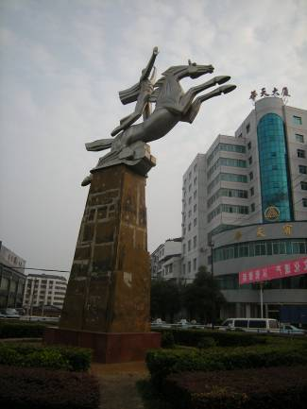
The horse statue is situated in the middle of a large round about. It is said to represent the “take-off of Qiyang economy.” When I arrived in Qiyang, this was the first eye-catching landmark I saw as we drove into town!

Government Square was recently built a few years ago. It boasts an impressive line of Government buildings. Apparently a small fortune was spent on this area. Opposite the Government buildings, the Square is very popular for locals as it has lots of activities available such as roller skating, rollerblading, park area with playing/exercise equipment, carnival games i.e. balloon shooting (see photo below). You can get a mini-bus from the school to the main cross intersection of Government Square, and then it is about a 10 minute walk to the actual Square. Alternatively you can take a taxi or one of the “bigger buses.”
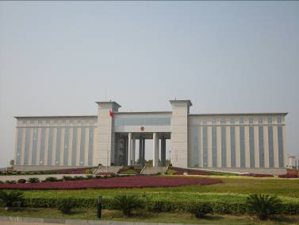
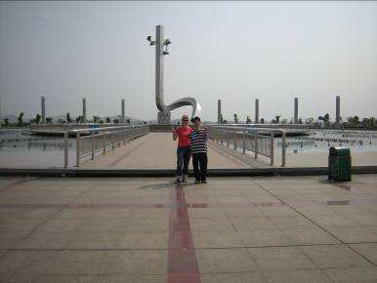

One of the buildings at Government Square Centre feature at Government Square
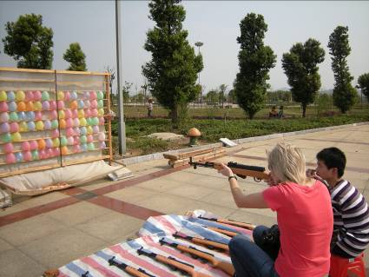
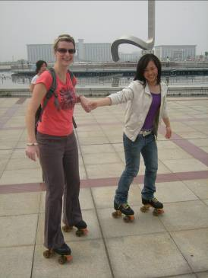

Carnival games (2 Yuan for 15 pellets) Roller-skating (5 Yuan for as long as you like!)
There is a Martial arts school about 20 minutes from the school (by mini-bus). For a fee, you can learn Chinese boxing & Tai Chi. If you are interested in this sort of thing, the FAO or even some of the students can tell you more about this.
I am told there is a “cinema” in town, but I have never been. Apparently you just turn up, pay a small fee and choose a movie from the DVD library and the movie of your choice is played on demand.

There is a bar/nightclub in town, not far from the #1 supermarket. It is fairly modern and very clean and it wasn’t too crowded the night I went. The staff treated us like royalty, but it was quite expensive though. The music was typical Chinese dance/pop music and there were two live singers in between the DJ sets. We (I was with the other foreign teacher) danced and drank with the locals – it was a fun night and I was merely curious about the Chinese nightlife in Qiyang, so in that respect, one visit there was worth it! It closed around midnight. This is definitely an ‘outside of school adventure’ that you should consult your FAO about.

In town, near the riverbank (around the corner from the Old Tree Cafe), I have just recently discovered that there is a recreation marquee set up with Billiard tables. It’s a fairly simple set up, but it’s worth checking out! For two games of pool and a 600 ml bottle of beer, I paid 6 Yuan. The locals are friendly too and may even ask you to play with them...Maybe even pay for your games of pool too!
Adjoined to the #1 supermarket, there is a computer game arcade. It is very noisy and crowded, but if you like that sort of thing, then you will enjoy it.
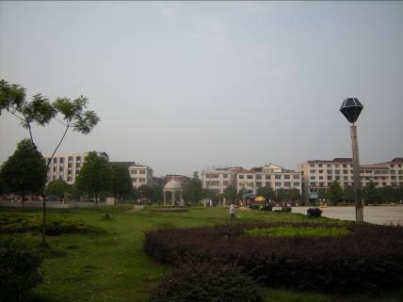
In town, there are park areas where the locals love to exercise on the park equipment and practice Tai Chi. Some locals even dance in the street, sometimes with music, sometimes without. It creates an uplifting atmosphere that’s for sure!
Of course there a many KTV bars here, but I have not ‘indulged’ myself in that experience as yet… I am still working up the courage to go!!

If you like relaxation ‘things to do’, then I can recommend a place near the #2 supermarket (near the photo printing shop). On level 3, you can have all kinds of treatments such as a foot wash & massage – extra 10 Yuan to have your toenails cut, neck & shoulders massage with hot beads and they also do Chinese medicine there. I had 4 treatments and I was there for at least 1 ½ hours and I paid 58 RMB and it was well worth it! On the same road, but further down, you can get a relaxing facial that lasts for about 1 hour. I am not sure of the price as one of my Chinese English teacher friends “treated” me.
There is also a newly constructed 4 star hotel here in Qiyang called the Xinli Hotel. It is a short walk from Government Square. A few weeks after arriving here, I met a local couple in the #1 supermarket. They are super friendly and always happy to help with anything I need and often invite me to their home for dinner. They are fairly well connected in Qiyang and they just happen to have contacts with the owner of this hotel, so on a few occasions, they have treated me to a pampering hair wash/massage session which is absolutely heaven!
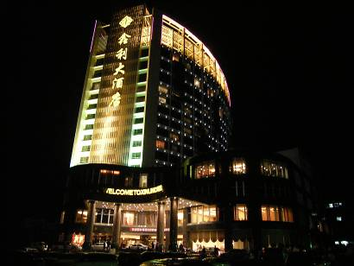
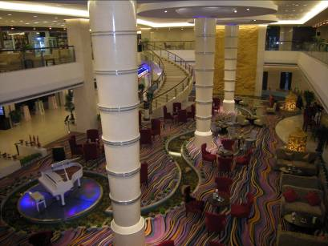
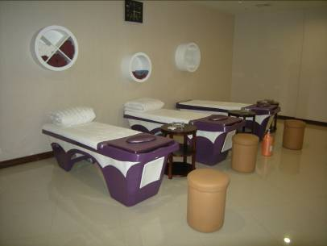
Front entrance of the hotel Lobby area Hair wash/massage room

Transportation/ travelling
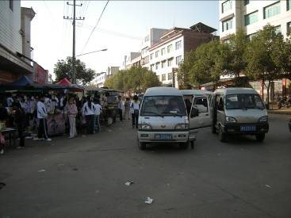
The mini-bus is the way to go into town for sure! It costs only 1 Yuan one way and it takes approximately 10-15 minutes to get into town, depending on which part of town you want to go to and the level of traffic. There are always mini-buses going passed or waiting by the school ready to go. They will go, even if you’re the only passenger at the time. The mini-buses start very early (the earliest I have caught a mini-bus is 8 am, but I think they start earlier than that) and they seem to stop running by approximately 9:30 pm/10:00 pm. The mini-bus is by no means a luxury ride, but I actually prefer the mini-bus ride compared to the taxi because of all the different people you get to see who get on and off all the way until you reach your stop. The mini-bus will stop anywhere (on their route of course) to pick you up and drop you off – it’s great!

Mini-buses waiting at the bottom of the hill from the school (short walk from the apartment). To the left, you will find the small supermarket – very convenient!

I rarely catch a taxi because it costs 10 RMB one way into town and more if you want to go further. As opposed to the mini-bus, the route is quite far and the most you’ll ever pay one way is 1 Yuan. The taxi is convenient though if you have your hands full with groceries or if the mini-buses have stopped running for the day. You never have to wait long for a taxi and they drive you right up to the school gate (the mini-bus stops at the bottom of the steep hill of where the school is located).
There are bigger buses that you can catch near the school, but I rarely use them. The mini-bus is always there 99% of the time, if not, it’s only a short wait.
There is a train station here, but I have never used it. It is at least 20-25 minutes from the school and I have asked the FAO where it travels to, but he was unsure. Because Qiyang is a small town, he said it wouldn’t go to any big cities. That is as much as I know or have been able to find out about the Qiyang train station.
If you want to venture out of Qiyang to other places in China, it is a small mission to get to a bigger city where you can get a train that can take you to a bigger city where there is an airport. Alternatively, there is a larger bus terminal that has many coaches. I used the coach system when I went to Guilin. It was a 4 hour journey from Qiyang to Guilin. I have some Chinese friends who are well connected in Qiyang and they helped me get the coach ticket. Apparently it can be difficult to get a bus ticket as there are too many people who want to travel and not enough seats! On the other hand, if you want to take the bus to Yongzhou City, it is just a matter of going to the smaller bus terminal and getting on the bus and waiting for the seats to “fill” before the bus departs. I have never waited longer than 30 minutes and sometimes I have been the last passenger to get on, so no wait at all! It costs 12 RMB (one way) to Yongzhou and it takes approximately 45 minutes – 1 hour to get there.
When you are travelling outside of the school, the school is very protective of your actions outside of the school. You will be required to write a signed statement explaining where you are going, when, how you’re getting there, the contact name/number of the person you are visiting and basically state that if anything “bad” happens to you whilst you are travelling or doing activities outside of the school , then you do not hold the school responsible. They make it clear that it is for your safety, not to restrict your freedom. Apparently this is common in other schools too. Of course when I go to the supermarket or out for dinner in town, it is not necessary to write such a statement.
The people/food and the culture
The people in Qiyang on the whole are really friendly & make you feel very welcome. They are very curious about you. I am the only female foreigner in this town, so I get a lot of stares literally every time I go out. Sometimes they stop me randomly in the street to get a photo with/of me – sometimes they ask, other times they try to do it on the sly! The people can be really frank at times & other times they can be quite shy.
The people here never seem to be in a hurry and just go along their daily business in a relaxed manner. Other times they can be quite loud with each other – they really like to talk loud here! They also spit a lot, pretty much everywhere, including inside shops. This is just something that I turn a blind eye to.
A lot of men smoke cigarettes here, which I think is fairly common all over China. They smoke everywhere, and I mean everywhere! In the mini-bus, the bank, in restaurants, the supermarket etc. In Chinese culture, it is not well accepted for women to smoke, especially teachers, so if you’re a smoker, then don’t advertise it in public as it will give the students a “bad” impression of you. The school allows me to smoke in my apartment; of course I checked carefully for their permission first as this can be a sensitive topic if you are female smoker.
The locals litter everywhere here. I rarely see bins in the street and I see the occasional street sweeper and garbage removal truck. The rubbish doesn’t “look” nice, but surprisingly, it doesn’t smell. I think the locals “burn off” the rubbish frequently. From time to time, I will see locals scouring through the garbage piles looking for recyclables or I have even seen someone eating from the rubbish. There are several beggars on the streets too. Some will come up to you to beg for money but they are fairly harmless I think, others will just sit by a busy shop/street and very candidly display a health issue i.e. a big gaping wound in their leg and “hope” that it will attract people’s attention for a monetary donation.
The locals are also into blaring their vehicle horns. They use the horn as an indicator or an alert, so horns are constantly going off. It can get quite noisy and sometimes rather annoying! The locals also love to let firecrackers off and fireworks. Again, very noisy, especially when the firecrackers set off vehicle alarms too (!), but kind of amusing to see/hear them going off at all times of the day, sometimes close to midnight. I don’t hear them every day, but they are a common occurrence. It is one of those things that you end up naturally adapting to or zoning out from!
Barely anyone speaks English here. There are no travel agents here and I am at least 4 hours from an airport. I believe Changsha and Guilin are the closest airports to Qiyang. There is very little Western food here & limited Western brands available. There is no McDonalds or KFC in Qiyang, but in Yongzhou, there is a KFC, but the chips are more like McDonalds fries and there is a Dico’s which is the Chinese version of KFC. In Qiyang, there is a small Chinese style “restaurant” that serves chicken style junk food and I have to admit, it’s pretty good for a Western food junk hit!
The school uses a meal ticket system for the canteen meals i.e. 1 ticket = 1 Yuan. The school charges 2 RMB for breakfast, lunch is always free of charge and dinner is 3 RMB. It is very inconvenient to obtain the meal tickets, so when you do buy them, make sure you stock up! I usually either do my own cooking for dinner or buy dinner outside of the school at a “hole in the wall restaurant” which is only 5 RMB and it is a well balanced meal & value for money! It is just a short walk from the school, so it is very convenient. You just point to the ingredients you want and they cook it up fresh for you, served with a bowl of rice of course! You can go to a “proper” restaurant in town and have a Chinese meal that can cost from 15 RMB or choose a Western style meal that costs from about 50 RMB. There are 2 Chinese restaurants that have a basic Western menu. One is called ‘The Old Tree Cafe’ and I don’t know the English name of the other restaurant (or if it even has one), but it is just around the corner from the #1 supermarket called ‘Better Life’. Some of the menu is in English, but be warned; the pictures don’t always depict what actually comes out on your plate! But remember, part of the fun is trying out new things, carry your phrase book or if you really need translation help, call your FAO!
There is a small supermarket located near the school (very short walking distance). There are also fresh produce markets located near the school. It is best to purchase your fruit and vegetables and eggs from these markets rather than the supermarkets – the market freshness is unbelievable!
In town, there are 3 supermarkets. We nickname them #1 supermarket (Better Life), #2 and #3! All three supermarkets have two levels. Food is predominantly on the 1st floor and the 2nd floor caters for other items such as bathroom care, electrical appliances, clothing, kitchenware, cleaning agents etc. It is not uncommon for me to have 10 shop assistants trying to help/or watch me choose a product i.e. hair conditioner + about ½ a dozen customers standing around watching my every move. It is a bit bizarre – sometimes I feel famous & sometimes I feel like an alien!
This is a small town, so I cannot post mail overseas, only within China. If I want to send mail overseas, I have been told I have to travel 45 minutes to Yongzhou to do it. I learned the hard way. I once sent a birthday card overseas, paid for all the stamps and special envelope that the clerk insisted that I needed only to have the birthday card returned to me 2 weeks later. Apparently the clerk was a new staff member and was not aware of his error at the time. It has also been somewhat difficult to receive mail from overseas. In the end I received all the mail that I was expecting, bar one letter. On another occasion, the mailman got my school confused with another school and my mail went to the wrong school. The students opened my mail, but a student from my school somehow found out about this and was very apologetic and he returned my mail to my apartment. The mail itself was not damaged.
My tips
- Smile a lot and make friends with the Chinese [easy to do...some locals do speak English! and you never know who or where you will meet people!] Having said that, there are also many Chinese English private language school teachers that are on the hunt for you to teach in their school or find out personal details about your Buckland contract – I never disclose my contract details to anyone, as required by the contract). I am always polite, but you can usually tell when they are wanting more from you rather than them just being friendly to the foreigner!
- Get to know some of their top stars (by name is usually enough).
- Know some basic key Mandarin phrases [they will love it, even if you show them that you can try just a little!]
- They love music [especially Westlife and the Backstreet boys] & movies.
- They love to sing and always ask me to sing & dance! – If you have a musical instrument that you can play, bring it if you can – that will be a big hit!
- They love to smile & laugh.

Final words
I would suggest bringing a few small items from home to make your apartment “feel like home” i.e. family photos or decorating your apartment with a few small trinkets to make it feel more “homely”. I am a big animal lover, so I asked the school’s permission to get a pet rabbit and they agreed that I could keep my rabbit on my apartment balcony. It is nice to have a pet around if that’s what you’re used to. When I go away, a student or one of the C.E.T.’s looks after my rabbit for me.


Me and Scamp
I am really glad I brought my own laptop as I have all my music, photos, movies etc at my fingertips. The download speed is extremely slow here, so don’t rely on it to download movies/music when you arrive. YouTube is also inaccessible. It’s also great having the webcam on my laptop so I can Skype with family and friends. If you haven’t already, I recommend setting up a Skype or an MSN account to keep in touch with family/friends and it’s free! Also, before you leave your orientation group at Buckland’s ask to exchange email addresses with the other foreign teachers in your group. It’s good to have new friends/contacts that are on the same wave length as you! Buckland’s also has a recreation DVD/book library that you can loan from. When you have finished with them, you can just mail them back to Buckland’s. I’m glad I took this opportunity as it takes a while to “get into the swing of things” and learn how and where to find things in your new town, so it was really convenient to have DVD’s and a novel on hand. As this is a small town, I have also had trouble finding movies that are in spoken English, or at least with English sub-titles, but they are around, you just have to hunt for them! I have hired 3 DVD’s for 5 days which cost me 3 Yuan, but I paid 10 Yuan. When I returned the DVD’s, I got the 7 Yuan reimbursed.
I have tried to provide as much detail as possible so you know what to expect. Of course I couldn’t possibly tell you everything, in the end; it is just a matter of making a decision and coming here to experience it for yourself! I am a first time foreign teacher and a first time traveller to China (or Asia for that matter) and I have found Qiyang and this school to be quite suitable for me. It’s an easy going atmosphere, the food is great, the people are friendly and the school looks after you. If you are looking for the “real China” experience then Qiyang is the place for you!
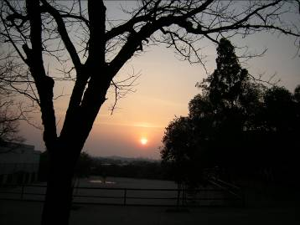
Don’t forget to bring your positive – go with the flow – attitude ☺ ….and sometimes, if you’re not sure what to do, “do as the Chinese do”! They may think and do things very differently to Westerners, but they sure are practical in so many ways! Things don’t always go smoothly, so don’t expect them to. Just be patient and remind yourself that you’re not in your home country and the reasons why you wanted to come here in the first place! So, just “go with the flow” and take it all in, the good and the bad and you will be rewarded with an experience of a lifetime ☺ The time goes quickly in China, so make the most of it while you’re here!
Sunset over the school basketball court

